

Dear Safeguarding Lead / Registered GP

**NAME OF SURGERY**

**Re:**

**Date of Birth:**

**Address:**

**CHILDREN AT ADDRESS –**

Please be advised that your patient was referred to a Multi-Agency Risk Assessment Conference [MARAC](https://www.norfolk.gov.uk/safety/domestic-abuse/information-for-professionals/multi-agency-risk-assessment-conference-marac) on ; because an assessment has shown that they are at high risk of current or future harm because of domestic abuse.

Please also be mindful of how this notification is recorded in the patient’s notes especially if the patient has consented to “online access”. You may want to contact the safeguarding teams for advice on how to manage subject access requests.

**Details of incident**

The patients **has not/has** given consent. However, under the MARAC protocol, relevant and proportionate information can be shared without the consent of the victim as the case has been judged high risk. Guidance can be located [here](http://www.safelives.org.uk/sites/default/files/resources/Marac%20Guide%20for%20GPs_Final_25.07.17.pdf). MARAC is fully GDPR compliant in accordance with the new regulations and the MARAC Operational Guide has been updated accordingly.

**This letter serves as notification only. PLEASE DO NOT INFORM OR CONTACT THE VICTIM as this could put them at increased risk.**

All agencies that take part in the MARAC meetings have to be aware of the Confidentiality Agreement as outlined on the relevant Case List.

Please take the following actions:

1. Check your patient’s details and recorded address and notify the Norfolk MASH if different.
2. Check if there are any other potential victims registered at this address.
3. Please consider sharing any information you may hold which might indicate that she/he is a victim of domestic abuse. For example any documented injuries, disclosures or mental health issues or any other information you hold which suggests increased vulnerability.
4. Please share any additional information which you judge to be relevant to protect this victim or other victims.

If you have any queries about the MARAC process and the safeguarding notifications please call 01603275726/6326 or 6021

Alternatively if you have any relevant information that you wish us to be made aware of please email [marac@norfolk.pnn.police.uk](mailto:marac@norfolk.pnn.police.uk)

Kindest regards,

Norfolk MASH

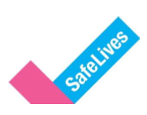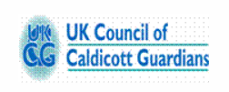**GP Information Sharing Guide for MARACs**

A **MARAC (Multi Agency Risk Assessment Conference)** is a victim-focused meeting where multiple agencies share information to develop a safety plan for High Risk domestic abuse victims. Agencies include Police, Social Care, Health, Probation, Mental Health, IDVAs & Housing. **All agencies must sign a declaration of confidentiality prior to taking part in the MARAC process.**

There are **three guides** for GPs to advise them of how to share information for MARACs:

1. **SafeLives –** ***‘MARAC - Guidance for GPs’***
2. **Department of Health/UK Council of Caldicott Guardians – *‘Practical Guidance on the application of Caldicott Guardian Principles to Domestic Violence and MARACs’***
3. **CAADA & Royal College of General Practitioners – *‘Guidance for General Practitioners’***

**SafeLives - *‘MARAC - Guidance for GPs’***

Has a section on ‘How to Share Information Safely at a MARAC’ which displays a table of legal Acts information can be shared under without consent (see below).

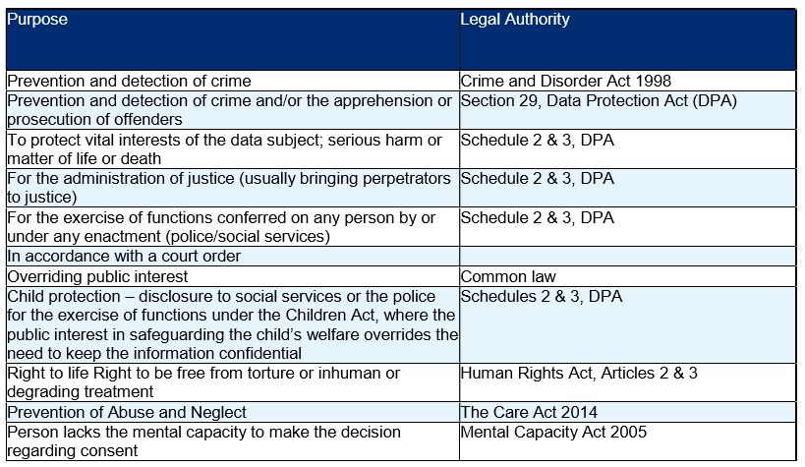

**Department of Health/UK Council of Caldicott Guardians**

Explains the **‘Caldicott Principles’** and how **MARAC must comply with ALL principles**.  
1. Formally Justify the Purpose – *It can be justified in the individual’s best interest.*2. Identifiable Information when Necessary – *Identifiable information is necessary.*3. Only Minimum Required Used – *Proportional disclosure based on risk.*  
4. Need to Know Access – *MARAC needs to know (Agencies sign a confidentiality declaration).*5. All Must Understand Responsibilities – *MARAC statement read aloud prior to meeting starting.*6. Comply with/understanding the Law – *Caldicott Guardians should ensure ‘Caldicott Compliance’.*

**CAADA & Royal College of General Practitioners – *‘Guidance for General Practitioners’***

Explains that the primary health care teams role is to *‘Share information appropriately.* ***In exceptional circumstances information may be shared without the patient’s consent.*** *Some cases considered at* ***MARAC meetings are likely to constitute exceptional circumstances*** *because MARACs discuss the most serious cases of alleged or suspected domestic abuse.*

*For further information, please read the official guidelines as listed above. Information on this document is a brief summary of each guideline. It is advised you read the full guidelines.*