Herbert Protocol - Missing Person Information Form

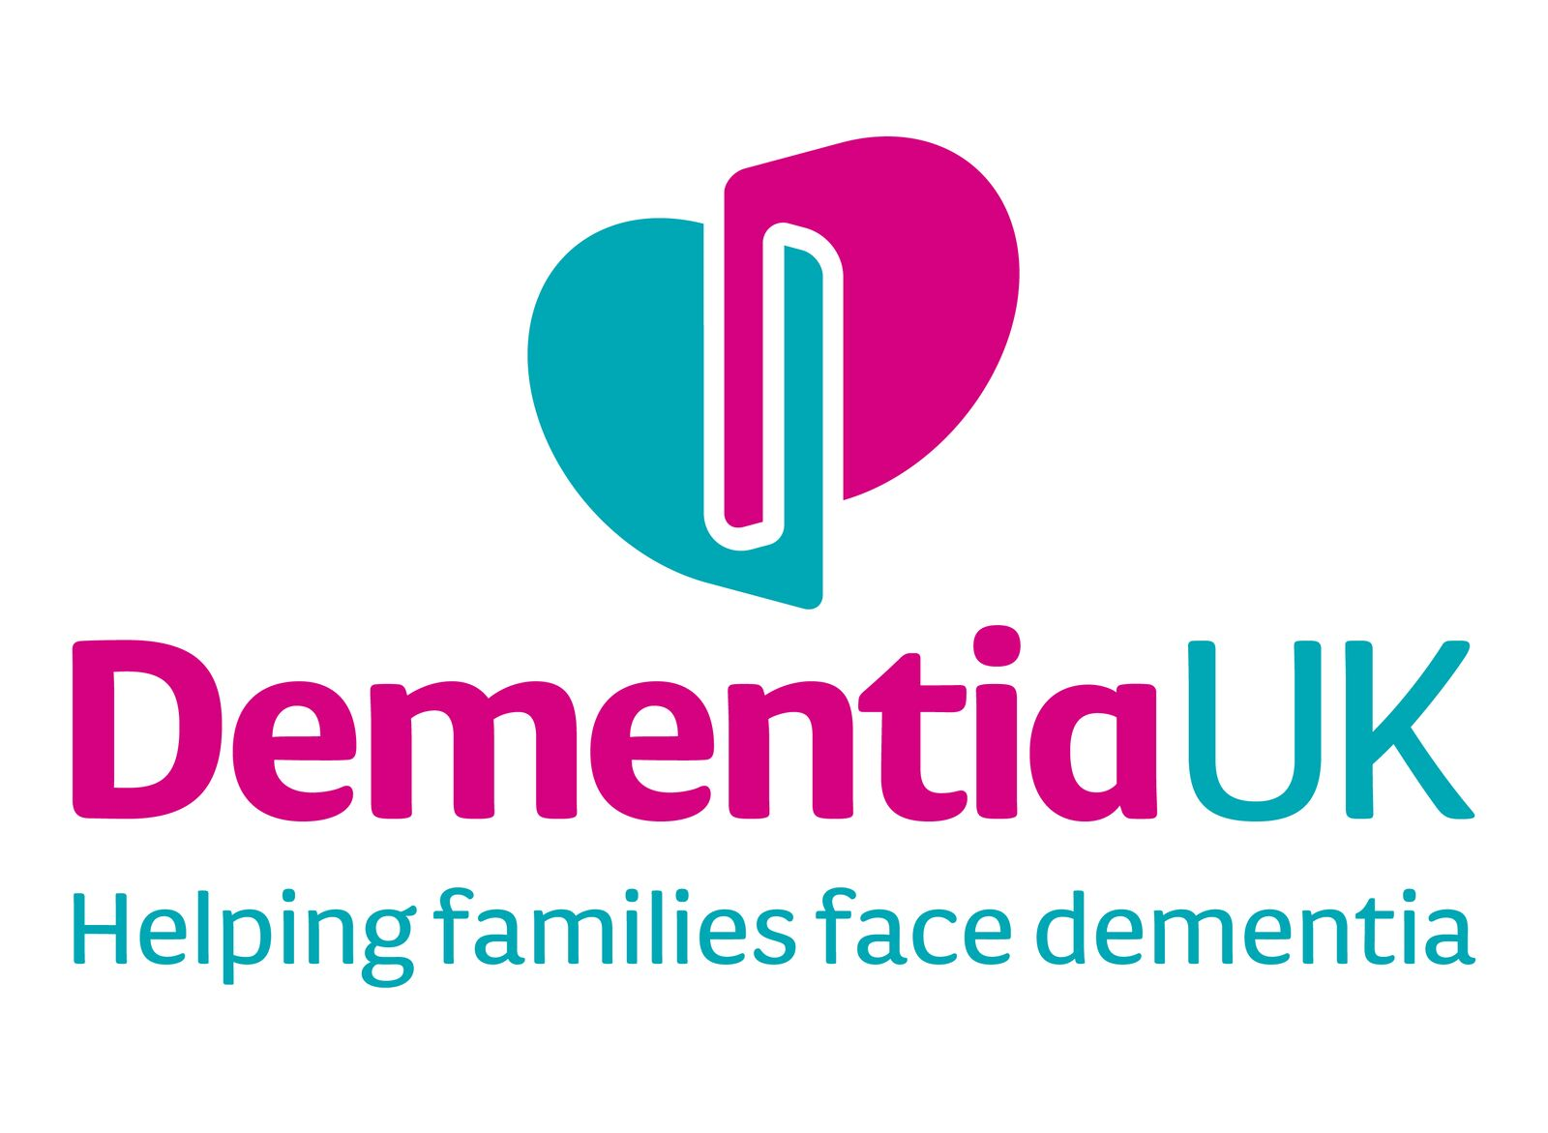

If you are concerned about the whereabouts of your friend/relative, then you MUST call the police on 999.
Someone who has dementia, memory loss, mental ill health, a learning disability or other cognitive difficulties or health condition may be at greater risk of going missing or more vulnerable if they were to go missing (e.g. if they require medication at a set time or if they are not able to communicate with people who may be able to help). The Herbert Protocol document provides information about a person that can help others, like the emergency services, to build a better understanding of who the person is, and help to locate them quickly should they go missing. Recording this information ahead of time and keeping it regularly updated will greatly reduce stress associated with trying to recall detailed information in an emergency situation.
There may be important pieces of information that you are able to provide the police in the event that the person you are caring for has gone missing. Try and have several copies of recent, close-up photographs of the person, this may help the police when searching for them.

Please fill in as much as you can and keep it in a safe place where it can easily be located if the person it refers to goes missing. You may want to make several copies which can be kept safe by neighbours or relatives or places where the person tends to often be (e.g. school, work, day centre).

This form is designed to be completed by a friend/family member/neighbour/care worker or other appropriate person working with the vulnerable person.

Where possible the person to whom this document refers should consent to its completion and the sharing of information if they get lost or go missing.
However, if the person lacks mental capacity to consent, then an appropriate person such as family member, Next of Kin or Lasting Power of Attorney can consent to sharing this information in the person best interests if they genuinely believe that the person maybe at risk of harm.

** This section is to be completed PRIOR TO the individual being reported missing**
Part 1 – to be completed when an individual has been identified as at risk of going missing
Full name (of person at risk if they were to go missing): |  |  |  |  |  |  |  | **Attach a recent photo here**  It may help if you have an electronic photo so it can be emailed to the police who will send it to those involved in the search.
Preferred name:

Date of Birth |  |  |  | Age:
Ethnicity:

Current address:

Mobile telephone number
Carer/Spouse/ Next of Kin/ Lasting Power of Attorney – Name, Contact Telephone & Email:
Part 2 – Previous Addresses (Inc. approx. dates)
Part 3 – Background, Family & Friends (Inc. names and addresses if known)
Part 4 – Current and past interests (e.g. education, employment, places of interest and places visited (Inc. approx. dates they last visited)
Part 5 – Personal history of individual that has been identified as at risk of going missing

Part 6 – Further Information
Habits (e.g. drink, drugs, biting nails, collecting items)
General Description (e.g. skin colour, hair colour, height, weight, build)
Distinguishing features (e.g. marks, scars and tattoos)
Particular item of clothing always worn (e.g. coat / jacket / footwear)
Has the individual got a GPS tracker? (e.g. BUDDI) Yes / No
If YES, what are the details:

Does the individual have access to money / funds? Yes / No
If YES, banking institute used and approx. amount:

Public Transport used (e.g. number 54 bus to Castle Meadow from bus stop outside the corner shop)
Part 7 – Vulnerability Factors
Hearing and eyesight (Condition):
Mobility (e.g. walking stick, scooter)
Other physical & mental health issues:
Medication:

Best method of communicating?/ Communication difficulties
Things that can help them feel at ease/calm down if distressed
Things that may cause worry or upset:
If previously missing, where were they located?

Part 8 – Routine / Visits / Activities & Groups / Shopping
 | MORNING | AFTERNOON | EVENING
Monday
Tuesday
Wednesday
Thursday
Friday
Saturday
Sunday

Please use this space to record any other relevant information about the individual:

Full name: _____________________________________ Signature: ____________________________________

Full name of person giving consent if individual is unable to: _______________________________________

Contact telephone: ___________________________

Relationship to the individual: _______________________

I agree that the information in this leaflet may be shared with emergency services and health and social care professionals for safeguarding purposes.

Signed: ____________________________________ Date:___________________________

Remember, if you are concerned about the whereabouts of a friend/relative who has cognitive difficulties then you MUST call the police on 999 at the earliest opportunity. It is quite normal to worry about dialling 999. Some people are concerned that they will be criticised for calling the police, but if you are worried about a person's safety then this will not happen. Please let the police control room know that you have a Herbert Protocol when you report them missing.

** This section is to be completed AT THE TIME the individual is reported missing **
Description
Outerwear (e.g. coat / jacket)
Headwear
Scarf
Gloves
Footwear
Jewellery (e.g. watch, rings)
Were they carrying anything (e.g. bag / umbrella)
Are they likely to have a mobile phone with them? If so, what is the current mobile number?
Pet (if they were with one) (Inc. name / type / breed & colour)

When was the person last seen? (date & time)
Where was the individual last seen?
Were they supposed to be going anywhere/meeting anyone? If so, please provide details
Name of individual who last saw the person | Name: ____________________________________________  Contact telephone:__________________________________
When did the individual last medicate?
When is medication next due?
What will the impact be if the individual does not take this medication?
Other risk factors (please tick this that apply)

Suicidal Depressed Confused Anxious Violent Alcohol Other (please describe)

Any other information relating to the individuals current physical or mental health:

Are you happy to approve a media release?

