All partners are being asked to help raise awareness of Courier fraud in Norfolk.
Here are 3 quick and easy things you & your service can do

 | Action | Where to use the information
1 | Text for news story / bulletin:  Norfolk Constabulary are currently dealing with a number of courier fraud incidents, in which fraudsters are purporting to be police officers, in order to scam members of the public out of large amounts of money.  Courier fraud is where fraudsters call victims pretending to be police officers, often from London, tricking them into handing over significant amounts of cash as part of a policing operation. Fraudsters can adopt a range of techniques to facilitate this, for example, they can make the victim believe that their local banking branch are using counterfeit money, or that counterfeit money is being transferred into their account and they need to withdraw the cash and hand it over to an officer or courier for examination.  Typically, these fraudsters most commonly target elderly people as they could be more vulnerable firstly, as they are likely to be accepted for credit and secondly because they may have a large retirement fund/pension. They are also trusting of the police.  In the last few months Norfolk has seen a significant rise in reported calls in which fraudsters have falsely claimed to be police officers. As a consequence, a number of individual victims have lost significant amounts of money which have been handed over to couriers.  As a response to this crime we have been using a number of platforms to raise awareness of courier fraud, and have since identified a number of avenues that have been used as part of the scam. This includes ongoing work with banks around Norfolk as well as Taxi firms, which are often used to transport elderly victims to the bank to withdraw the cash. These have proven successful with a number of incidents being interrupted after suspicions were raised and subsequent arrests made.  We are encouraging our partners to help raise awareness of this crime in order to prevent residents becoming a victim of it. If you are dealing with an individual who may have become withdrawn or worried about money, then don’t hesitate to ask questions.  Please contact Norfolk Police on 101 if you believe someone has been the victim of courier fraud. Always call 999 if an emergency.  Further information to upload to the website includes:  - Your bank or the police will NEVER ask for your PIN, bank card or bank account details over the phone – never give these details to anybody.  - Neither the police nor the banks will send a courier to collect money from you.  - Always request Photo ID and if unsure call the police.  - If you're asked to telephone a bank, then always do it on a different phone to the one you were contacted on.  - Fraudsters will keep the line open and have been known to play ringtones, hold music and a recorded message down the phone so the victim believes they are making a call to a legitimate number. Ensure you can hear a dialling tone before calling police or use a friend or neighbour's telephone instead.  - Do not rush into complying to the scammers demands / requests.  - If you have already given your bank details over the phone or handed your card details to a courier, call you bank straight away to cancel the card  Officers are particularly keen for members of the community to ensure they contact family and friends, particularly elderly relatives to ensure they are aware of these scams and the warning signs. | Website  Newsletters  Email alerts  Staff team meetings or briefing
2 | Use the following social media posts attaching the graphic below  Tweet | 1  There is an increased threat from courier fraud in Norfolk. Please be aware, tell your colleagues, friends & family. #NorfolkScamAware @NorfolkPolice @NorfolkCCTS  Tweet | 2  Be #NorfolkScamAware and keep yourself and others safe from scams:  - Be cautious and trust your instincts  - Protect your financial information  - Never give personal details to cold callers  - Never click on links or open attachments in unexpected emails or texts  Tweet | 3  Your bank or the police will NEVER ask for your PIN, bank card or bank account details over the phone – never give these details to anybody. Be #NorfolkScamAware & keep yourself and others safe from scams. Be cautious and trust your instincts @NorfolkPolice @NorfolkCCTS  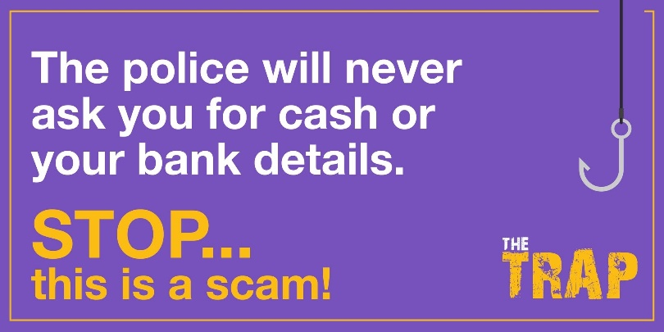 | Posts Twitter/Facebook/Instagram
3 | Norfolk Against Scams Partnership (NSAP)  NASP is a partnership of organisations committed to taking a stand against scams.  The partnership’s ambition is to make Norfolk a scam free county.  NSAP have produced a number of products to help raise awareness of scams. Please use these across your organisation  See https://www.norfolk.gov.uk/business/trading-standards/scams/norfolk-against-scams-partnership  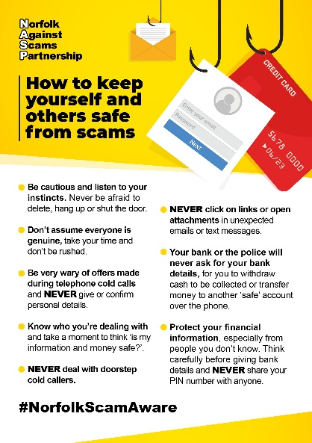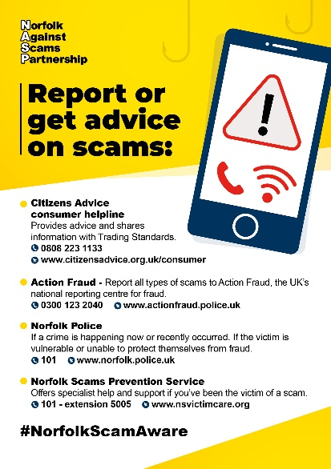  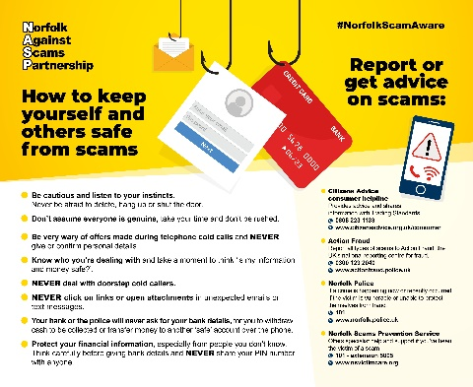 | Website  Newsletters  Email alerts  Staff team meetings or briefing

