Coalition for Change
Join Us!

 | We want people with learning disabilities and/or autism, their families, or their carers to join our group.
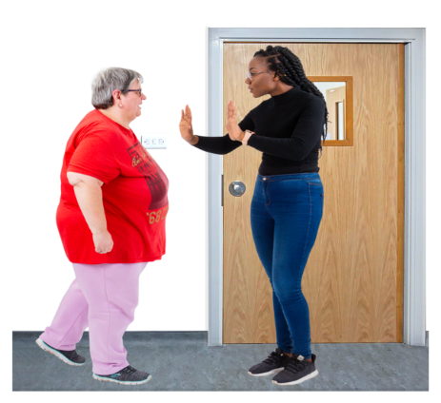 | We especially want to find people who know what it is like to stay in a locked door hospital or home.  And their families or other people who help them as well.
 | We have a Core Group of people that plans how our group will do its work. The Core Group needs help with this work.
 | Task 1: We need to find out which services work well and which ones do not
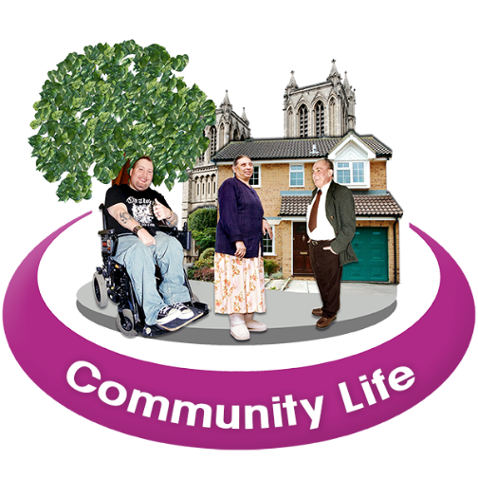 | Task 2: We need to make sure that people have enough support to live the lives they want in their local community.
Join Us! | We want 6 people to join the Core Group to help with the work.  Or you can just sign up to get information from us.
Membership of the Core Group is free.

Signing up to get information from us is free.

The Core Group meets every 6 weeks for 1 hour.

Meetings are online. We can help you to get online if you need this.

 | We can provide support before, during and after any of the meetings to make sure you have time to ask questions and take part in all decisions.
 | Core Group members will be paid for taking part in meetings.
Website:  Coalition for Change Web Page | If you want to join, please let Tracey Jones (email address below) know how to contact you and whether you want to be:  - Core Group  - Information Only  Email:  tracey.jones@norfolk.gov.uk

