GP Information Sharing Guide for MARACs

A MARAC (Multi Agency Risk Assessment Conference) is a victim-focused meeting where multiple agencies share information to develop a safety plan for High Risk domestic abuse victims. Agencies include Police, Social Care, Health, Probation, Mental Health, IDVAs & Housing. All agencies must sign a declaration of confidentiality prior to taking part in the MARAC process.
There are three guides for GPs to advise them of how to share information for MARACs:
- SafeLives – ‘MARAC - Guidance for GPs’
- Department of Health/UK Council of Caldicott Guardians – ‘Practical Guidance on the application of Caldicott Guardian Principles to Domestic Violence and MARACs’
- CAADA & Royal College of General Practitioners – ‘Guidance for General Practitioners’
SafeLives - ‘MARAC - Guidance for GPs’
Has a section on ‘How to Share Information Safely at a MARAC’ which displays a table of legal Acts information can be shared under without consent (see below).
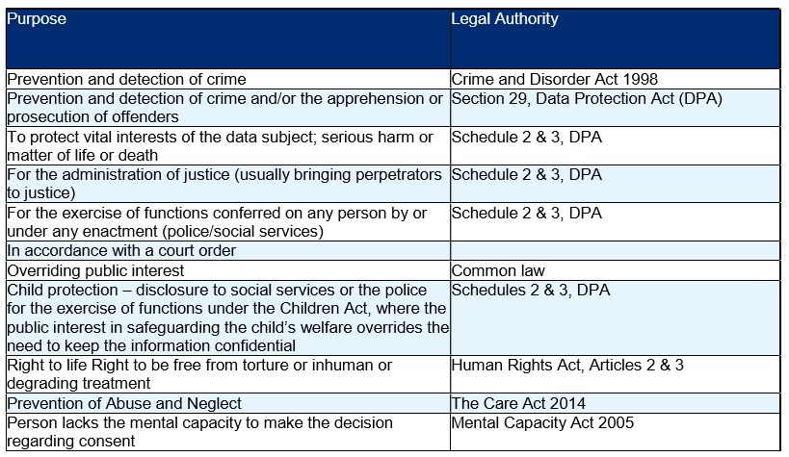
Department of Health/UK Council of Caldicott Guardians
Explains the ‘Caldicott Principles’ and how MARAC must comply with ALL principles.
1. Formally Justify the Purpose – It can be justified in the individual’s best interest.
2. Identifiable Information when Necessary – Identifiable information is necessary.
3. Only Minimum Required Used – Proportional disclosure based on risk.
4. Need to Know Access – MARAC needs to know (Agencies sign a confidentiality declaration).
5. All Must Understand Responsibilities – MARAC statement read aloud prior to meeting starting.
6. Comply with/understanding the Law – Caldicott Guardians should ensure ‘Caldicott Compliance’.
CAADA & Royal College of General Practitioners – ‘Guidance for General Practitioners’
Explains that the primary health care teams role is to ‘Share information appropriately. In exceptional circumstances information may be shared without the patient’s consent. Some cases considered at MARAC meetings are likely to constitute exceptional circumstances because MARACs discuss the most serious cases of alleged or suspected domestic abuse.

