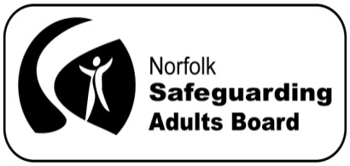
Norfolk Safeguarding Adults Board Manager’s Blog
March 2015
Welcome to the first Norfolk Safeguarding Adult’s Board Manager’s blog.
I started in my role as Board Manager on 26 January 2015 and have been attending the Board’s subgroups and Locality Safeguarding Adults Partnerships (LSAPs) to meet the many people from the Board’s partner agencies who are involved in safeguarding adults at risk of abuse and neglect in the county.
It has been a very busy couple of months as the Board has recently been restructured to ensure it is ready to fulfil its responsibilities when it becomes a statutory body on 1 April 2015, when the Care Act is implemented. The Board’s subgroups and LSAPs are also working hard to get the Board ready for statutory status. There is a diagram to show the new structure of the Board on our website.
The Board’s website was originally set up in September 2014 as a resource for professionals working in the area of safeguarding adults. If you have any feedback on how the website could be improved, we would very much like to hear from you via nsabchair@norfolk.gov.uk. In the meantime, I was told about a case recently which I thought illustrated everything the Board and its partners are trying to achieve:
People are able to live a life free from harm, where communities:
have a culture that does not tolerate abuse
work together to prevent harm
know what to do when abuse happens
Mr P
The Norfolk Safeguarding Adults Team was alerted to an incident which highlighted excellent multi-agency partnership working across Board member agencies, to safeguard a man at risk of abuse in Norfolk.
Mr P has dementia and is supported by a local home support agency. His neighbour told his carer Mr P had written a cheque for £900 for the cleaning of his guttering and washing the drive way. The agency immediately contacted Mr P’s son who had the cheque stopped. He also asked the carer to put the cheque book in the medication safe until he could visit. The agency reported the incident to the police.
Later that week, when the carer attended Mr P's lunch call, she found three men inside. They said that they had come for their money as they hadn't been paid. Mr P said that he was looking for his cheque book to pay them again. One of the men said as the carer had arrived, they would return a little later.
The carer reported the matter to the office and the agency manager asked her to wait down the road to see if the men returned. The carer reported that the men had returned and the manager rang the police who attended the property within minutes. The carer had taken down the car's number plate and details. The three men, who had gained entry to the property again, were arrested and taken away by the police, and were subsequently placed on Police bail.
Mr P’s social worker was alerted and work has been done with Mr P and his son around keeping him safe from rogue traders in the future.

