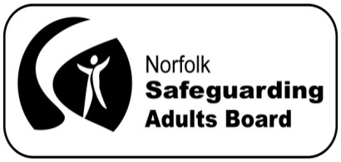
Norfolk Safeguarding Adults Board Manager’s Blog
May 2015
Over the past month, Jan (the board’s Business Support Officer) and I have been working with the chairs of the board’s subgroups and locality partnerships, and our statutory partners, to prepare the Safeguarding Adults Board’s annual report. I’m pleased to say that the report is now complete and will be published on the website later this month. In accordance with the new Care Act guidelines, copies will be sent to:
- the Chief Executive and leader of the local authority
- the Police and Crime Commissioner and the Chief Constable
- the local Healthwatch
- the Chair of the Health and Wellbeing Board
Pulling together information from groups and services involved in safeguarding in Norfolk has emphasised how much work has been carried out in the county over the past year, to work with people with care and support needs, to keep them safe from abuse and neglect.
The Norfolk Safeguarding Adults Board is conducting a survey of Norfolk residents to find out what people already know about safeguarding. The survey will run from 11 May 2015 until the end of July 2015. The results of the survey will inform the critical work of safeguarding adults services in the county. The survey will be publicised widely and can be completed either online at the following link:
http://www.smartsurvey.co.uk/s/norfolksafeguarding
or over the telephone, by calling 0344 800 8020. The survey should only take about 5 minutes to complete, so if you can possibly spare the time to fill it in, your views would be very much appreciated.
The board has agreed to hold a safeguarding awareness raising week during the week commencing 7 September 2015. The locality partnerships are planning events and activities that will run throughout the week across the county. Events discussed so far have included a ‘family fun day’ at the local Early Help hub, stands in local supermarkets and a safeguarding workshop involving local faith groups. The Communications and Publicity subgroup are working hard to develop refreshed and updated publicity materials in time for the event.

