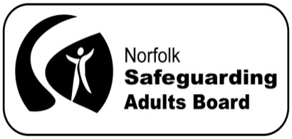

Norfolk Safeguarding Adults Board Manager’s Blog

October 2015

Why loneliness and Hate Crime are safeguarding issues

It’s now the start of my second month and there has been no let up in the pace. A couple of events have caught my attention. Both helped me think more about the scope of adult safeguarding and the six principles which shape our approach.

A recent publication from the Office of National Statistics, on older people's well-being, makes interesting reading. http://www.ons.gov.uk/ons/dcp171766_418058.pdf

In it, Jennifer Thomas summarises some of the risk factors associated with loneliness - such as living alone, housing tenure, marital status, ill health and support networks. Her paper got me thinking about the possible wider impact of loneliness as a factor in increasing a person’s vulnerability to abuse. A news story on the BBC website about loneliness and the risk of fraudulent mail (financial abuse) reinforced this idea - see Loneliness and the risk of fraudulent mail - BBC News, 2 October 2015.

At the end of September the 4th Norfolk Older People’s Strategy 4th Norfolk Older Peoples Strategy 2016-18 was published. One of the issues it also addresses is the impact of loneliness. We should all be mindful, whether as individual practitioners or colleagues involved in strategic discussions, that loneliness can increase a person’s vulnerability to abuse and harm. This is turn links us to working in a way which supports the protection principle as set out in the Care Act, see section 14.13
Care Act 2014: statutory guidance for implementation - Publications - GOV.UK

It was by chance that I read in the Eastern Daily Press about the 7th Norwich Vigil against Hate Crime, which took place on Saturday 17 October. So I went along to support it.

The vigil took place at The Forum on Millennium Plain in Norwich. Although it was small turn-out, this did not detract from the impact of the event. It was poignant listening to the short speeches and taking part in the two minutes’ silence in the candlelight. Hate Crimes are any crimes that are targeted at a person because of hostility or prejudice towards that person's disability, race or ethnicity, religion or belief or sexual orientation What Is Hate Crime? | Stop Hate UK Recent figures indicate a rise in reported hate crimes Reported hate crimes rise by almost a fifth | Society | The Guardian (13/10/2015).

Poppy Rose, one of the contributors who spoke at the vigil, put it much better than I can using poetry. Here is ‘There was a man’

There was a man who walked the streets,
his face like any other,
he wasn’t black he wasn’t white,
he was just a human colour.
There was a child who learned to hate,
upon his father’s knee,
learned to embrace intolerance,
hate and bigotry.

There was a young man so angry,
who walked the streets at night,
looking for a victim,
itching for a fight.

So shallow was his understanding,
so deep his hate and bigotry,
from lessons learned when he was young,
upon his father’s knee.

How many faces turned away,
how many cries went unheard,
when hate and bigotry walked the streets,
that night when no one said a word.

There was a man who walked the streets
his face like any other,
but now he’s dead a victim of hate,
he could have been your brother.

Strategies for the prevention of abuse and neglect are a core responsibility of a SAB. We are continuing to look for every opportunity to work with local groups and partnerships to understand and tackle issues in our communities, including loneliness and hate crime. This will help to shape our strategy going forward.

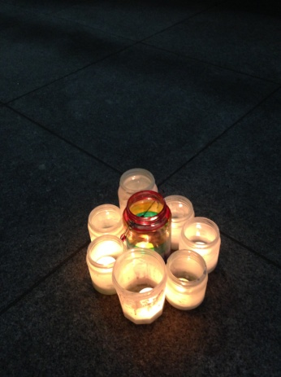

Walter Lloyd-Smith
Norfolk Safeguarding Adults Board Manager

